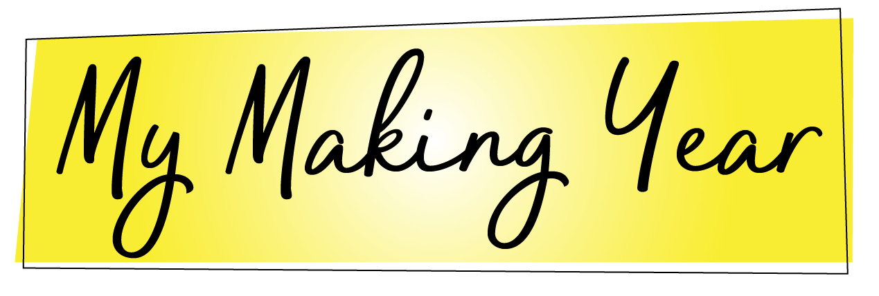
A Reflecting and Envisioning Worksheet

Date Completed: ________________________

Don’t let the end of one Making Year just bleed into another. Stop, reflect on what you’ve done, consider what’s been working and what hasn’t, and envision your goals and strategies for the next 12 months of making. Strive toward your goals within intentionality and planning.

Products
Reflecting:
What did I make in the last 12 months, and when?

Envisioning:
What do I want to make in the next 12 months, and when?

Units and Profits
Reflecting:
What did I actually sell last year?
- Total print books sold:
- Total e-books sold:
- Total page views on KU:

Units and Profits, con’t
What did I actually earn last year?
- Total profits:
- Profits per product:

Envisioning:
- How many books and e-books do I want to sell in the next 12 months? Per release?
- How much profit do I hope to make in the next 12 months? Per release?

What other metrics might be useful to set as goals? (trying for a bestseller, aiming to qualify for PAN membership in RWA, etc.)

Marketing and social media
Reflecting:
What went well in marketing and social media last year? What spaces felt the most productive for me? The least productive? Why might that be? Are there spaces where I should be, but am not currently? Are there spaces I am currently active in that aren’t serving me well?

What are my current numbers on my social media platforms and my website, including number of followers or likes, number of posts, number of site visitors, etc.? Am I satisfied with these? If not, what might I do to move these numbers?

Envisioning:
What social media platforms and marketing strategies do I want to prioritize in 2018? What are realistic goals for what it means to do those things well/effectively?

Networking
Reflecting:
Where did I make genuine connections with other professionals in my field in the last 12 months? What are some connections that I could have better maximized? How?

Envisioning:
Which people, groups, or organizations would I like to better connect with in the next 12 months? What might facilitate this?

Professional development/education
Reflecting:
Where did I learn the most about my craft, or about marketing in the last year?

Envisioning:
What educational or professional development resources do I already have that I’d like to better use in the next 12 months? What books, podcasts, websites, or articles do I want to incorporate into my creative year in order continue growing in my craft?

Three Goals/Resolutions for my Making Year:
1. Do-able (small):

2. Reasonable (medium):

3. Stretch (large):

10 Lessons Learned in my last Making Year

1.

2.
3.
4.
5.
6.
7.
8.
9.
10.

